**User Guide:**

*-* *Before using our website please take a look at these instructions:*

*+Our homepage has charts, list of top trending songs, ... if you are interested just click on one of the items will show the song or singer alblum You need to find*

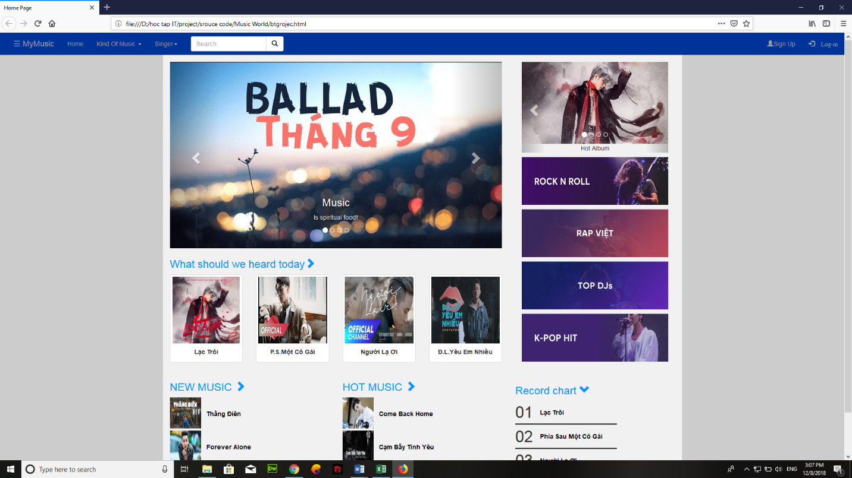*+If you want to open up the pages of the singer:*

*.click on singer button and select the singer you want to hear*

*+if you want to open up the pages of the kind of music*

*.click on the kind of music button and select the kind of music you want to hear.*

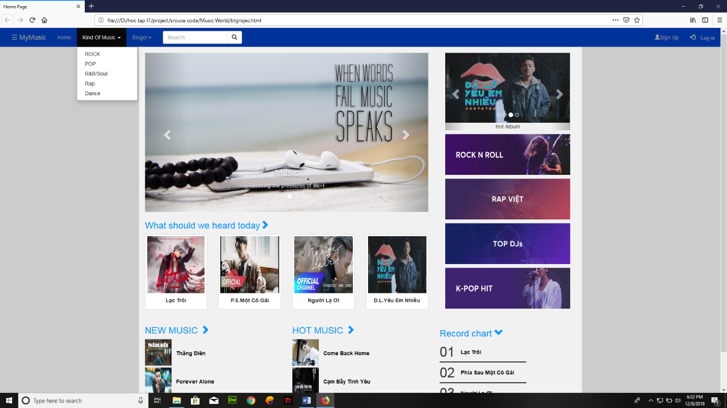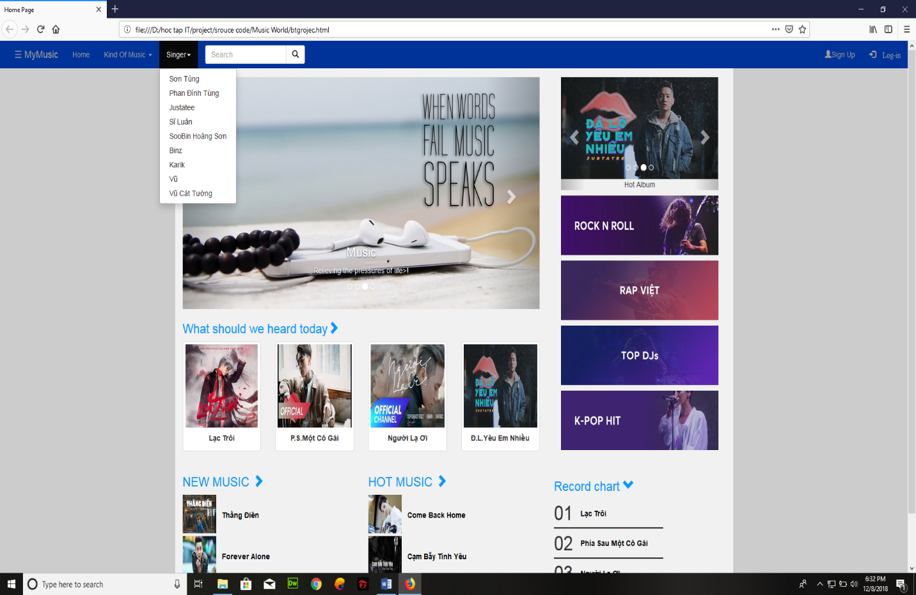

*-If you want to sign up please click the sign up button in the top right*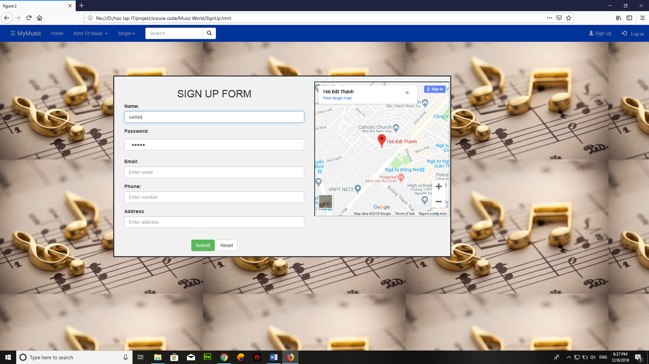

-This will open a popup window like this and the next thing you need to do is fill out the information,including:

+your name

+password

+email

+phone number

+address

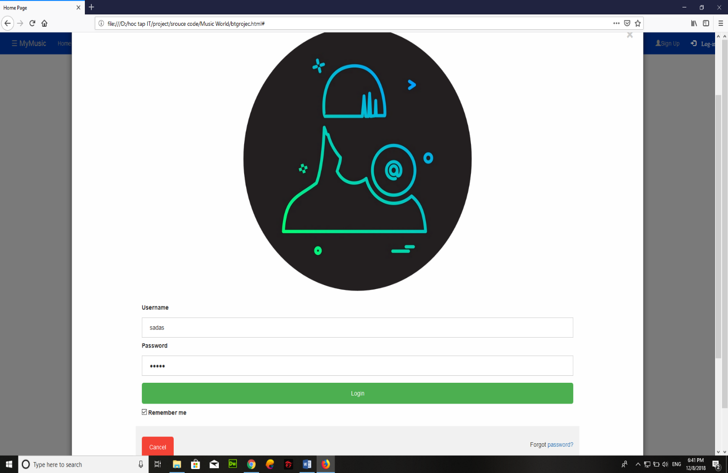-Once you have registered, you can login to the site by clicking the log-in button on the top right.It will open a window like this:

-you just need to enter your username and password.

And if you want to contact to us or have more question,please click to the MyMusic ,it will show you a menu which have the contact button like this:

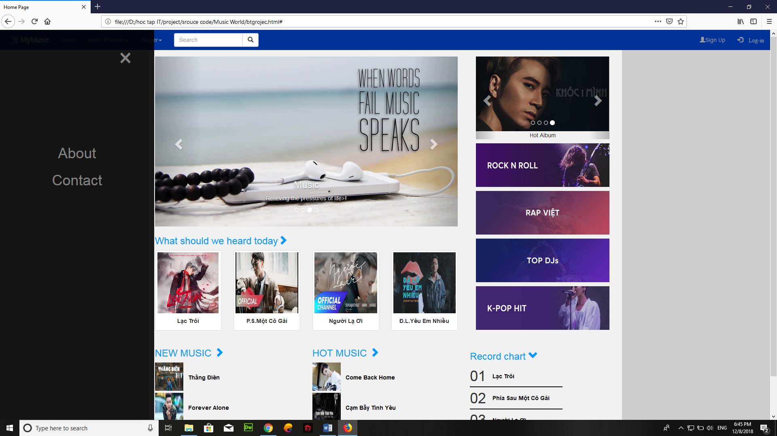

-click that button,it will lead you to the contact page:

